Lab 5 – My Solutions
Changing the settings:
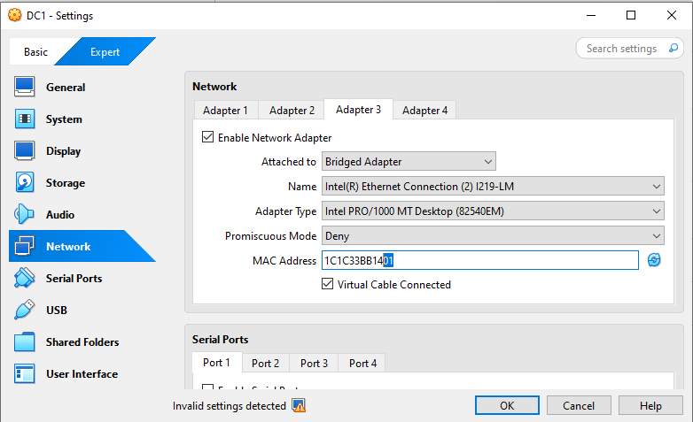
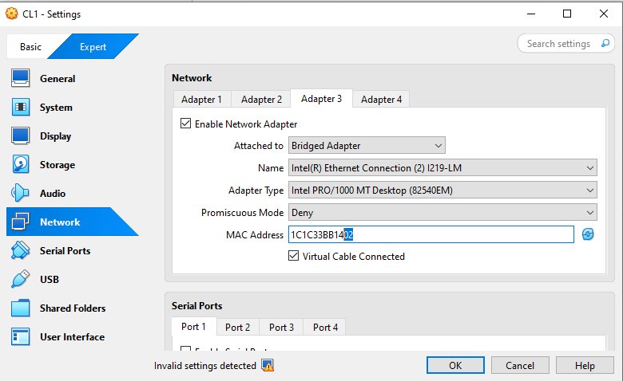
1: FTP - Anonymous Access
PowerShell:
Create folder and file:
New-Item -ItemType Directory -Path "D:\FTP" -Force
Set-Content -Path "D:\FTP\docs.txt" -Value "Hello this is a test file."
Install:
Install-WindowsFeature -Name Web-Server, Web-FTP-Server -IncludeManagementTools
Open inetmgr
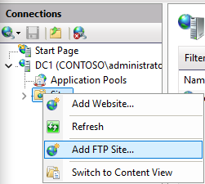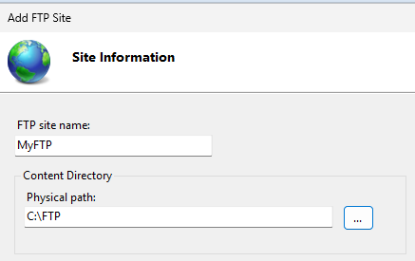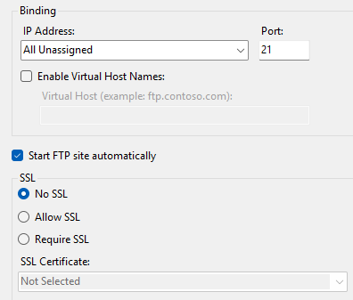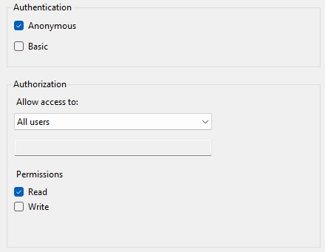
PowerShell:
Open firewall for FTP:
New-NetFirewallRule -DisplayName "FTP In" -Direction Inbound -Protocol TCP -LocalPort 21 -Action Allow
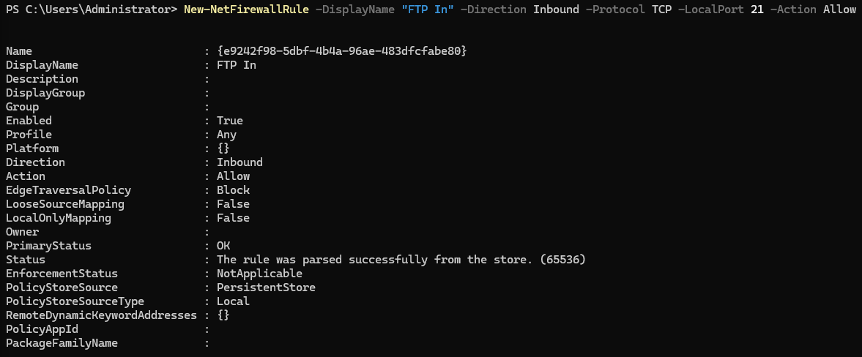
Check IP for FTP:
Ipconfig
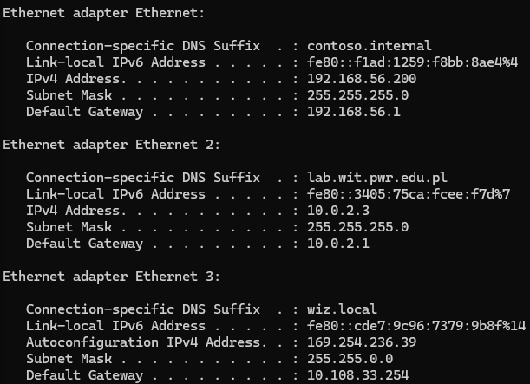
Ethernet = Internal network -> 192.168.56.200 ✅ (we use this internal for FTP)
Test
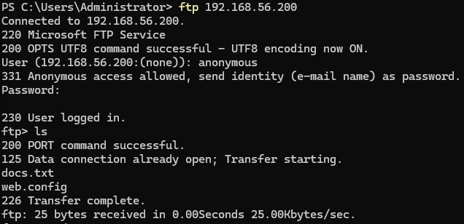

2: FTP - User Access
Create a user ftpuser and allow all users to read/write:
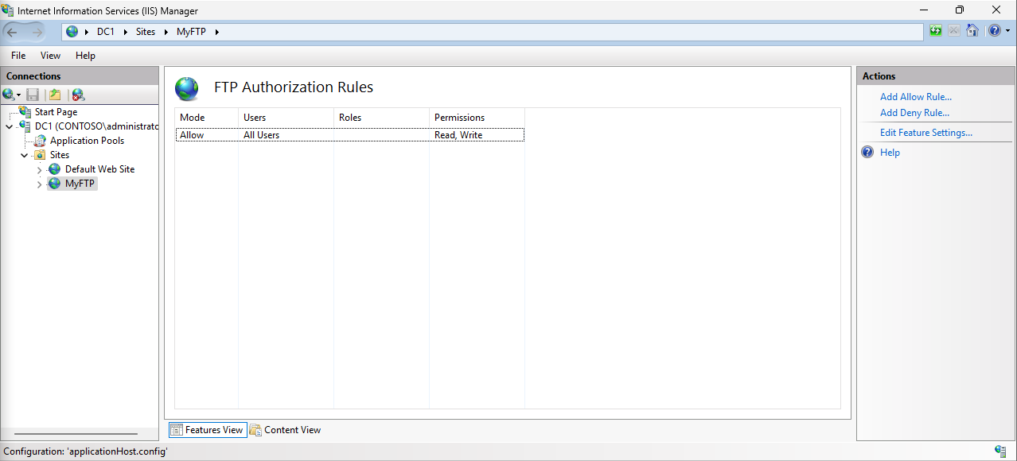
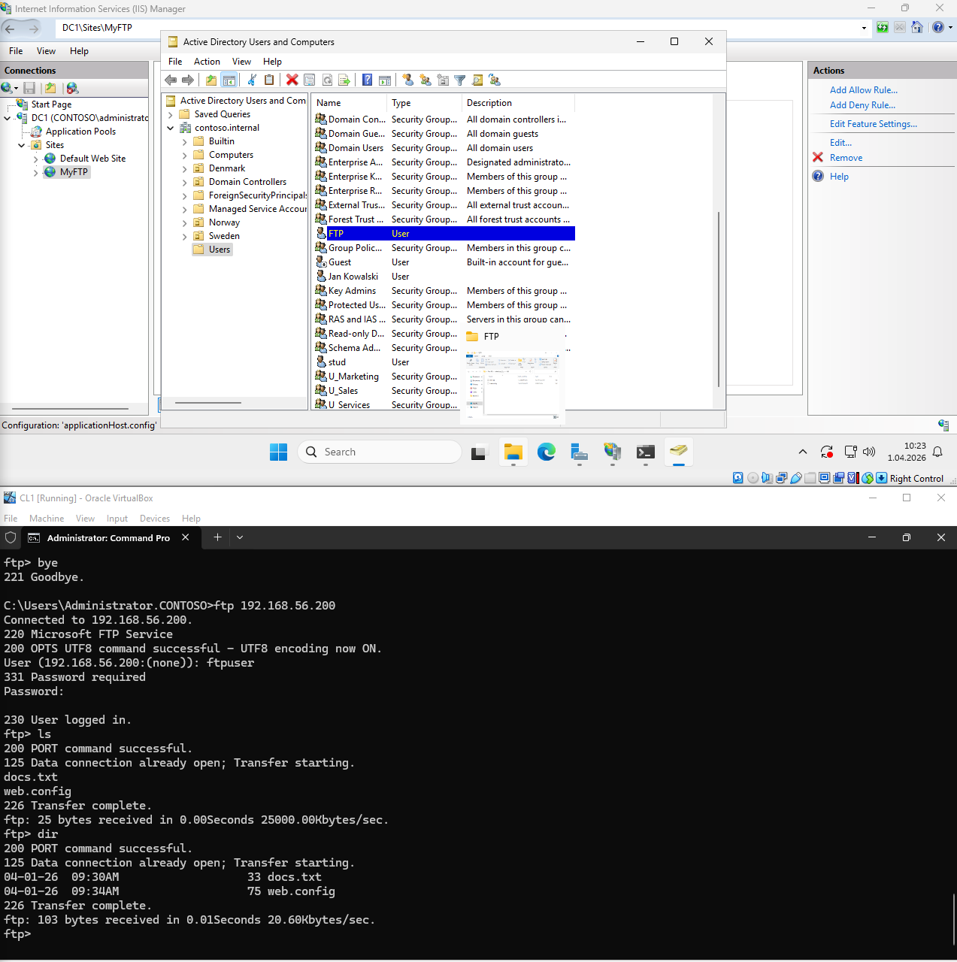
3: FTP - By NETWORK CARD
Check the internet address after the initial configuration of the internet ip:
